TEAM 2 Business Plan

1. App Name and One Sentence Description
App Name: Tablé
Description: A mobile and web-based marketplace application that connects consumers (diners) with nearby restaurants to offer real-time reservation availability based on live location data, transit modes and user preferences.

2. Problem: What, Who, Why
- What problem are you solving: Diners frequently waste time physically checking restaurant availability or navigating overcrowded areas, while restaurants simultaneously lose potential walk-in customers due to perceived busyness or lack of dynamic queue visibility.
- Who has this problem: Spontaneous urban diners, tourists navigating unfamiliar neighborhoods, and mobility-impaired individuals (EDI focus) who require guaranteed accessible and uncrowded seating environments.
- Why it is important: Existing platforms heavily prioritize reservations made days in advance. There is a significant market gap for a tool that empowers walk-in customers with real-time crowd predictions, reducing friction in urban dining and enhancing accessibility.

3. Solution: How
How you plan to address this problem: Tablé will ingest historical and dynamic OpenTable structured datasets alongside NYC Open Data. By training time-series machine learning models, the app will forecast peak dining hours and current busyness levels for specific restaurants. Furthermore, a Generative AI chatbot ("Dining Copilot") will be integrated to offer personalized recommendations based on real-time and predicted occupancy.

4. Target Users and Competitors
Target Users: Tablé serves a two-sided marketplace. On the consumer side, it supports spontaneous diners who need reachable, low-friction restaurant availability in Manhattan. On the business side, it supports independent restaurants that need to fill unexpected empty tables without publicly discounting their brand.
Target user segments and requirements:
User Segment | Side | Core Need | Requirement Implications for Tablé
Spontaneous Executive | Consumer | Needs immediate seating near office/hotel with low waiting time. | Map discovery within 1.5 km; visible availability; ETA-validated booking; concise confirmation flow.
Deal-Hunting Foodie | Consumer | Wants high-quality meals within budget and is willing to move quickly for discounts. | Budget/dietary onboarding; personalised flash-deal inbox; 15-minute countdown; clear expiry state.
Urban Explorer / Tourist | Consumer | Navigates unfamiliar Manhattan areas and depends on walking, cycling, or transit. | Manual neighbourhood fallback; transit mode support; route-aware booking guardrails; simple map interface.
Mobility-Impaired or Sensory-Sensitive Diner | EDI Focus | Requires confidence that a restaurant is accessible and not uncomfortably crowded. | Accessible/sensory-friendly tags; uncrowded recommendations; reduced-risk booking before travelling; readable UI states.
Independent Restaurateur | Business | Needs to fill sudden empty tables without public mass discounting or overbooking. | B-side dashboard; discount boundaries; targeted 1-to-1 offers; auto-termination when inventory is depleted.
MVP requirements derived from user stories:
Priority | Module | Requirement | Why it matters
P0 | Onboarding | Capture budget tier and dietary tags | Provides the minimum user profile needed for matching and recommendation logic.
P0 | Discovery | Show only restaurants within 1.5 km with available_table_count > 0 | Keeps the core user journey grounded in immediate, reachable availability.
P0 | Booking | Enable or block booking based on ETA versus 15-minute hold window | Reduces no-shows and protects restaurant inventory.
P0 | Offers | Expire flash deals after 900 seconds and disable acceptance | Supports time-sensitive yield management and prevents stale claims.
P0 | Dashboard | Auto-complete a campaign when all released tables are claimed | Prevents overbooking and closes the restaurant-side operational loop.
P1 | Discovery / Offers / Dashboard | Manual search fallback, cancellation, and discount validation | Improves resilience and usability if time remains after the MVP is stable.
Competitors: The market already contains mature reservation systems, but most competitors are designed around planned bookings, host-stand management or restaurant operations. The gap for Tablé is the combination of predicted busyness, immediate table availability, ETA feasibility and private flash-deal matching.
Competitor | Relevant Strength | Observed Limitation | Tablé Differentiation
OpenTable | Large discovery network, web/iPad support, reservation inventory. | Optimised for conventional reservations; no strong prediction of walk-in busyness or ETA feasibility. | Tablé focuses on immediate availability, predicted busyness and reachable tables.
Resy | Premium restaurant brand network and flexible inventory release. | High restaurant cost; limited platform coverage; less suitable for small student-built B2B2C experimentation. | Tablé targets lightweight manager controls and private lull-mitigation offers.
Yelp Reservations | Waitlist and consumer discovery through Yelp network. | Stronger as a host-stand/waitlist tool than predictive matching; limited personalised flash-deal logic. | Tablé links user preferences, location and restaurant inventory into one offer flow.
Eat App | All-in-one operations, analytics and guest management. | Feature-rich but restaurant-operations heavy; consumer immediate-deal experience is not the central value. | Tablé keeps the MVP narrower: discovery, ETA booking, offers and manager dashboard.
Tock | Excellent prepaid experiences and no-show reduction. | Built for events/prepaid bookings rather than spontaneous nearby dining. | Tablé addresses short-notice, local demand during unexpected lulls.

5. Architecture and Technology Stack
Frontend: Web client built via React.js (Next.js for SSR); Mobile cross-platform client deployed via React Native (Expo framework).
Backend API Gateway & Microservices: Node.js + Express handling api-gateway, reservations-service, and marketplace-service (flash deals). Live occupancy data streamed via Node.js WebSockets (realtime-service). ML confidence scores served asynchronously via Python FastAPI (ml-pipeline).
Data Layer: Relational user and restaurant metadata structured in PostgreSQL (Google Cloud SQL managed instance); Real-time status caches held in Redis (Google Cloud Memorystore); Time-series historical trends logged in BigQuery / TimescaleDB.
Deployment & Cloud Infrastructure: Containerized serverless environments running on Google Cloud Run or managed GKE Autopilot clusters to eliminate operations overhead for a 6-developer team.
External APIs: Google Maps API (Geolocation & Transit ETA), Firebase (Cloud Messaging), and Stripe integration for simulated deposit charges.

6. Development Plan: Timeline, Milestones, Risks and Mitigations
Timeline & Milestones: The project follows the COMP47360 sprint structure through the public demo at the end of July, with final paper and repository submission on 7 August. The plan below keeps each role accountable while leaving Sprint 4 and Sprint 5 for integration, testing and polish rather than late feature discovery.
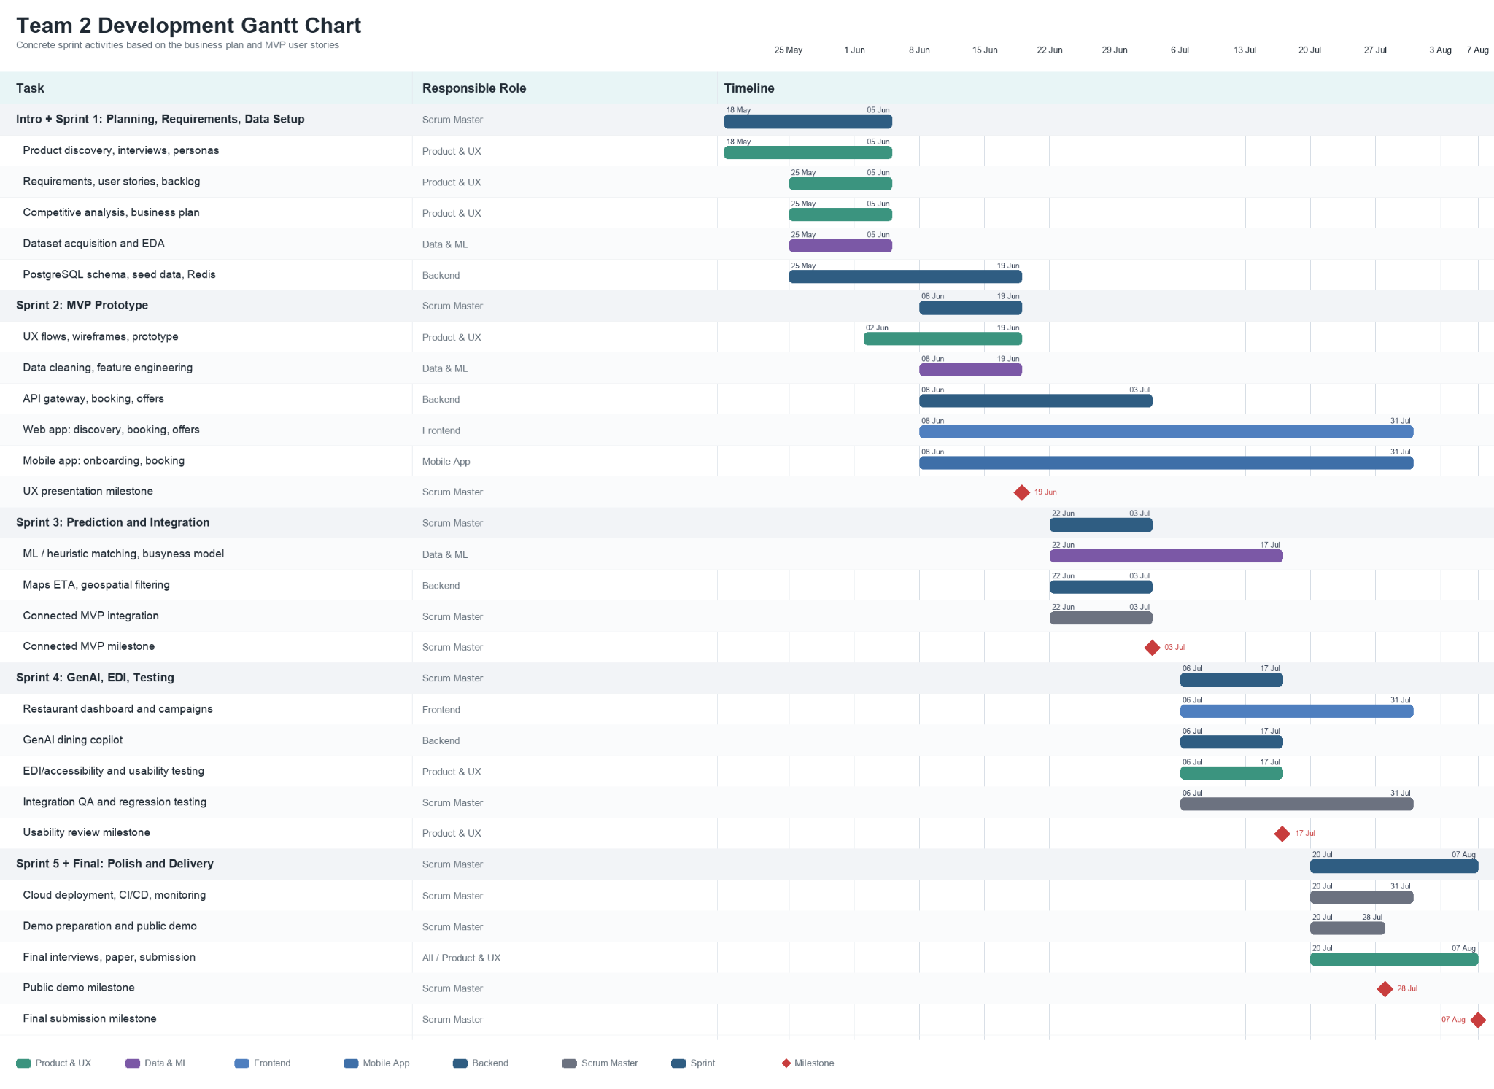
Milestone checkpoints:
Sprint | Dates | Milestone | Success Criteria
Intro + Sprint 1 | 18 May-5 Jun | Validated concept, personas, competitive analysis, user stories, MVP scope, architecture decision. | Product backlog ready; API contracts drafted; datasets selected; first prototype reviewed.
Sprint 2 | 8-19 Jun | Basic web/mobile skeletons, database schema, initial cleaning pipeline, first Product & UX presentation. | Onboarding, discovery and booking UI paths visible; baseline model plan documented.
Sprint 3 | 22 Jun-3 Jul | Connected MVP: backend, database, ML inference endpoint and core user journey integrated. | A user can complete onboarding, discover an available restaurant and attempt an ETA-validated booking.
Sprint 4 | 6-17 Jul | Additional features, GenAI Dining Copilot, EDI/accessibility improvements, usability testing and regression testing. | At least one user feedback round completed; highest-risk defects logged and prioritised.
Sprint 5 | 20-31 Jul | Demo-ready polish, cloud deployment, interview preparation, final paper drafting and public demo. | Stable public demo on 28 July; final code, backlog and paper ready for 7 August submission.
Risks and mitigations:
Risk | Project Impact | Mitigation
Limited real-time restaurant inventory | Live APIs may be unavailable or restricted. | Use historical/OpenTable-style structured data and simulated live updates for a defensible academic prototype.
ML model over-scope | A deep model may be unrealistic without rich labelled restaurant data. | Start with interpretable heuristic/baseline models; compare alternatives only when data quality supports it.
Google Maps / API cost | Repeated routing calls could exceed a student budget. | Call ETA once on restaurant detail load; cache results; use demo seeds and strict API quotas.
Integration complexity | Next.js, Expo, Node.js, FastAPI, PostgreSQL and cloud deployment can fragment work. | Define JSON contracts in Sprint 1, use a shared monorepo, and hold weekly integration reviews.
Usability and accessibility gaps | A map-heavy app can exclude users with mobility, visual or cognitive constraints. | Include manual search, clear status text, accessible contrast, larger tap targets and EDI tags in testing.
Demo instability | Live services may fail during public demo. | Prepare seeded demo data, a stable deployed build, local fallback screenshots and a scripted happy path.

7. Budget Specification
Monitoring budget performance remains the responsibility of the Product & UX Lead using daily timesheets. The revised estimate reflects a six-person team working from the introduction week through the public demo and final submission period. It includes product research, UX, data/ML, backend, web, mobile, testing, deployment, documentation and a 20% buffer for coordination, debugging and rework.
Feature / Task | Time Est. (hrs) | + Buffer (20%) | Total Time | Hourly Rate (€/hr) | Human Cost | Tools / Services | Service Cost | Total Cost
1. Product discovery, interviews & persona synthesis | 28 | +5.6 hrs | 33.6 hrs | €30/hr | €1,008.00 | Miro / Notion / survey tools | €0.00 | €1,008.00
2. Requirements, user stories & backlog management | 26 | +5.2 hrs | 31.2 hrs | €30/hr | €936.00 | Jira / GitHub Projects | €0.00 | €936.00
3. Competitive analysis & business plan refinement | 18 | +3.6 hrs | 21.6 hrs | €30/hr | €648.00 | Open data / market research | €0.00 | €648.00
4. UX flows, wireframes & Google Stitch prototype | 38 | +7.6 hrs | 45.6 hrs | €30/hr | €1,368.00 | Google Stitch / Figma | €0.00 | €1,368.00
5. Dataset acquisition, EDA & data-quality checks | 42 | +8.4 hrs | 50.4 hrs | €30/hr | €1,512.00 | NYC Open Data / OSM | €0.00 | €1,512.00
6. Data cleaning, feature engineering & merging | 48 | +9.6 hrs | 57.6 hrs | €30/hr | €1,728.00 | Python / pandas | €0.00 | €1,728.00
7. ML / heuristic matching and busyness prediction | 55 | +11.0 hrs | 66.0 hrs | €30/hr | €1,980.00 | scikit-learn / FastAPI | €0.00 | €1,980.00
8. Backend API gateway, booking and offer services | 58 | +11.6 hrs | 69.6 hrs | €30/hr | €2,088.00 | Node.js / Express | €0.00 | €2,088.00
9. PostgreSQL schema, seed data and Redis cache | 35 | +7.0 hrs | 42.0 hrs | €30/hr | €1,260.00 | Cloud SQL / Memorystore | €85.00 | €1,345.00
10. Web app implementation: discovery, booking, offers | 55 | +11.0 hrs | 66.0 hrs | €30/hr | €1,980.00 | React / Next.js | €0.00 | €1,980.00
11. Mobile app implementation: onboarding and booking | 58 | +11.6 hrs | 69.6 hrs | €30/hr | €2,088.00 | React Native / Expo | €0.00 | €2,088.00
12. Restaurant dashboard and campaign workflow | 38 | +7.6 hrs | 45.6 hrs | €30/hr | €1,368.00 | Next.js / dashboard UI | €0.00 | €1,368.00
13. Google Maps ETA and geospatial filtering | 28 | +5.6 hrs | 33.6 hrs | €30/hr | €1,008.00 | Google Maps API allocation | €75.00 | €1,083.00
14. Generative AI Dining Copilot integration | 22 | +4.4 hrs | 26.4 hrs | €30/hr | €792.00 | OpenAI API allocation | €60.00 | €852.00
15. EDI/accessibility features and usability testing | 28 | +5.6 hrs | 33.6 hrs | €30/hr | €1,008.00 | Testing devices / forms | €0.00 | €1,008.00
16. Automated tests, integration QA and bug fixing | 52 | +10.4 hrs | 62.4 hrs | €30/hr | €1,872.00 | Jest / pytest / CI | €0.00 | €1,872.00
17. Cloud deployment, CI/CD and monitoring | 28 | +5.6 hrs | 33.6 hrs | €30/hr | €1,008.00 | Cloud Run / hosting / domain | €95.00 | €1,103.00
18. Demo, final paper, presentation and interview prep | 63 | +12.6 hrs | 75.6 hrs | €30/hr | €2,268.00 | Overleaf / presentation tools | €0.00 | €2,268.00
TOTAL | 720 | +144.0 hrs | 864.0 hrs | - | €25,920.00 | - | €315.00 | €26,235.00
Budget control approach: each team member will record daily hours by feature/task. During sprint reviews, the Product & UX Lead will compare planned versus actual hours, flag over-spending areas, and de-scope P1 items before P0 flows are affected.

